W-11
YEAR 12 PHYSICS
TEST 4: ELECTROMAGNETISM

NAME: MARK:

1. Draw the nett (resultant) magnetic fields associated with the following.

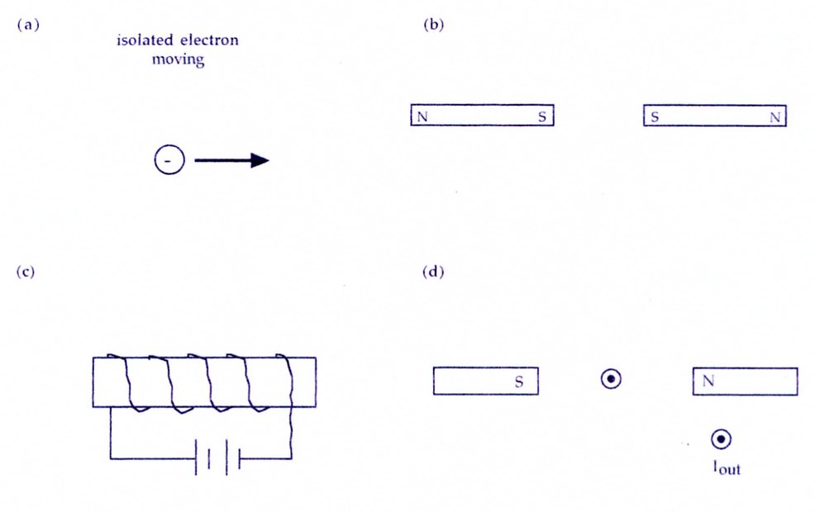

(6)

2. The diagram shows a solenoid switch that can be used to turn on a light. Describe how the switch works,
explaining how it can turn on the light.

(3)
3. An alternating current of 125 A flows a 50.0 m span of transmission cable that is orientated in a north-south
direction. The transmission cable is located at a point in Western Australia where the Earth's magnetic field
intensity is 5.40 x 10⁻⁵ T at 60.0 ° angle of dip. Assume the cable is horizontal along its length.

(a) At the instant that the current is flowing towards South, what would be the force acting on the length of
the wire?
B_{earth} = 5.40 x 10⁻⁵ T
North
I = 125 A South
60.0°
Looking west
South

(3)

(b) Given that the current oscillates at a frequency of 50.0 Hz, describe what would happen to the size and
direction of the force 0.02 s later.

(2)

4. A helium nucleus (charge + 3.20 x 10⁻¹⁹ C and mass 6.68 x 10⁻²⁷ kg) is accelerated by an electric field
produced in an "ion gun". The accelerating voltage used is 7.00 x 10⁴ V. It is then fired horizontally into a
uniform magnetic field of 0.100 T directed vertically upwards.

(a) Draw a diagram to show the path of the ion in the magnetic field.

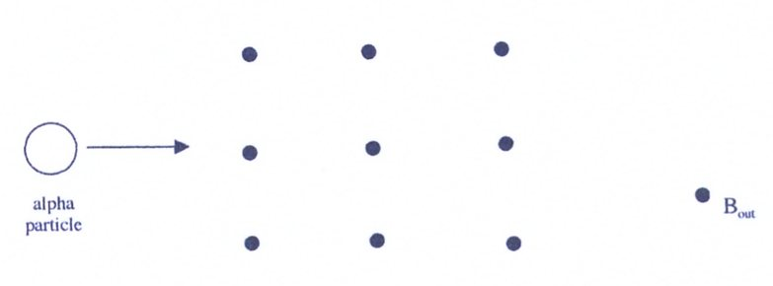

(1)
(b) Explain why the path of the ion has its particular shape in the magnetic field.

(2)

(c) Determine the velocity with which the ion leaves the ion gun.

(3)

(d) Determine the radius of the path of the ion in the magnetic field.

(3)

(e) Could the voltage in the gun be used to accelerate neutrons of mass 1.67 x 10⁻²⁷ kg? Explain your
answer.

(2)
5. The schematic diagram below shows an electric motor that produces its magnetic field from field coils either
side of the armature coil. It is called a series wound motor because the field coils X and Y are wired in series
with the armature coil.
Armature coil

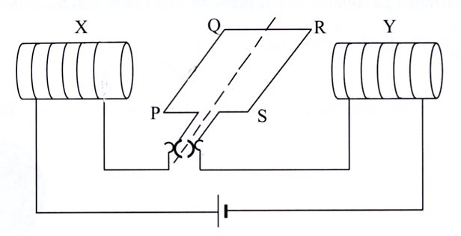
Field coil
Split-ring commutator

The armature coil of the motor has 150 turns. Side PQ is 5.00 cm long and side QR is 4.00 cm long. When the
armature coil is connected to the 12.0 V supply as shown, a current of 0.750 A flows the armature coil and the
field coils. The field coils produce a magnetic field of 0.0950 T across the armature coil.

(a) (i) Draw one arrow on the above diagram to show the direction of the magnetic field created by the
field coils X and Y. Label this arrow B.
(1)
(ii) Draw one arrow on the above diagram to show the direction of the force on the side PQ due to the
current in the armature coil. Label this arrow F.
(1)
(iii) Will the armature rotate clockwise or anticlockwise (as viewed from the point of connection to the
external circuit)?

Answer: (1)

(b) Calculate the force on the side PQ of the armature.

(3)

(c) Calculate the torque produced on the armature coil when PS is horizontal, as shown in the diagram.

(3)
(d) Describe and explain what occurs when the plane of the coil is vertical.

(2)

(e) State two ways in which the motor can be modified so that a greater torque is obtained.

(2)

(f) What is the purpose of the split-ring commutator?

(2)

6. Two parallel metal plates sealed in an evacuated chamber are 25.0 mm apart and have a potential difference
of 8.00 x 10² V. An electron, introduced into the electric field next to the negative plate, is initially at rest and
moves to the other plate.

(a) Determine the electric field strength between the plates.

(2)
(b) What is the force exerted on the electron?

(2)

(c) Calculate the acceleration experienced by the electron due to the electric field.

(2)

(d) With what velocity does the electron strike the positive plate?

(2)

